

|  |
| --- |
| Business Template  **Subject areas** |
| **Logo / Image** |

Contents

1 Business Description 3

1.1 Business background 3

1.2 Problems. Current Situation 3

1.3 The benefits of implementing a database. Project Vision 3

2 Model description 3

2.1 Definitions & Acronyms 3

2.2 Logical Scheme 3

2.3 Objects 3

# 

# Business Description

## Business background

This model connects job candidates with employers; it evaluates each candidate and makes a record about their current position, can be used in probably every job category

## Problems. Current Situation

Lot of information would need to be put it manually so it is time consuming and querying this especially into candidates and their skills area would be expensive

## the Benefits of implementing a database. Project Vision

This model does the skill matching well and give a lot of freedom to candidates to describe their skills, from the recruiters’ side it gives a great platform to plan the interviews and evaluate the candidates, companies have an easy platform where they can ask for the service of the recruitment company

# Model description

## Definitions & Acronyms

Company- an org that posts jobs for recruitment companies to pick up, POC here means person of contact

Jobs- these are the jobs that the company posts, isActive means if the job listing is still available for recruiters to pick up and is a boolean

Recruiter- these are the recruiters that work with the job applications and interviews

Job_application- is the application that the candidates submit(application_CV_link here should an URL)

Candidates- this table describes general information about the candidates

Job_skill and candidate_skill- these tables are there to handle m:m relationships (isRequired is a Boolean and means if the skill is required for the job or not

Skills- this table describes candidates skills

Interviews info table has the information about the interview details and interview_feedback has the evaluation/assessment of the candidate, interview_type here can mean if it is technical or general or other types

Education_information table has the info about where the candidate got the education if he got it at all, education level here can mean high-school, university, masters and so on

## Logical Scheme

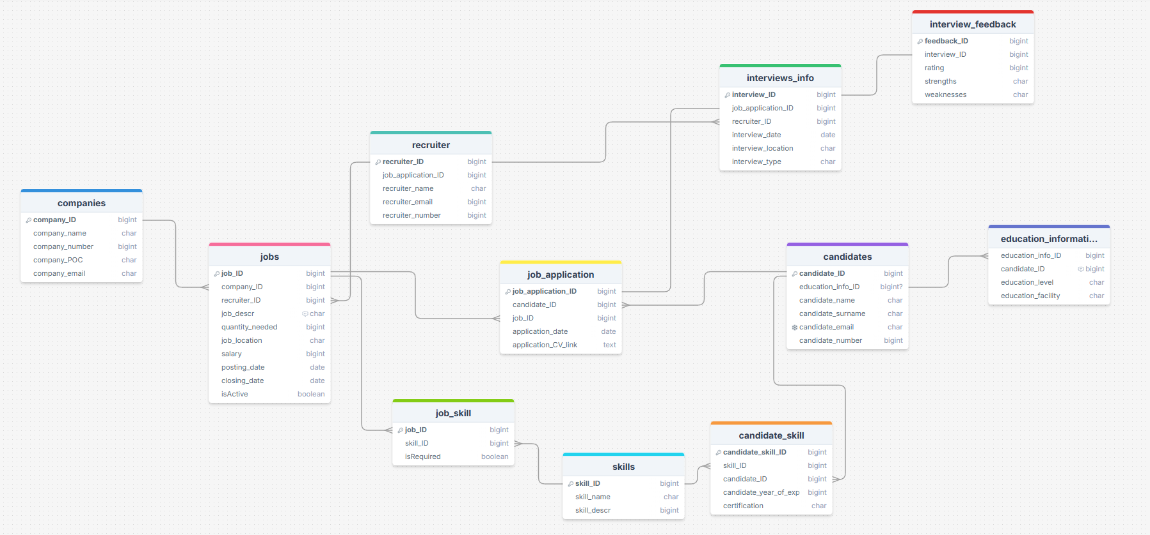

## Objects

All data types are present on the model itself

Table Description

<description>

|  |  |  |  |
| --- | --- | --- | --- |
| Table Name | Field name | Field Description | Data Type |
| Table 1 | Field Name 1 | <description>, PK/FK | Int |
| Filed Name N | <description> | Text |

Comments on table relationships

Example with data

|  |  |  |  |
| --- | --- | --- | --- |
| Field Name 1 | Field name 2 | Field name 3 | Field name N |
| 1 | aaa | 123 | 1234 |